Courtney Thurston

AP Art History

Mrs. Eckel

Etruscan and Roman Art



Figure 1: Karlie Kloss for Vogue UK

In the photograph above, American model Karlie Kloss poses for the affiliate of Vogue magazine in the United Kingdom. Much like the Greeks, we are still obsessed with the idea of bodies in motion. Many contemporary fashion magazines—like Vogue—photograph models not in stillness, but in motion. This style allows fashion photographers to capture the movement of clothing, but also allows us to study the human body as it moves, and the beauty that that motion can result in. From the image above, it is also clear that we are still obsessed with long, thin, crisp lines—in this photograph, her jeans and the lines of her arms are the contour lines that define the piece. Finally, it is worth noting that Kloss’ smile is much like one that can be seen in Archaic Greek style art—stoic-looking at first, but a subtle smile becomes clear the longer one stares at the image (or, in the Archaic sense, art work).

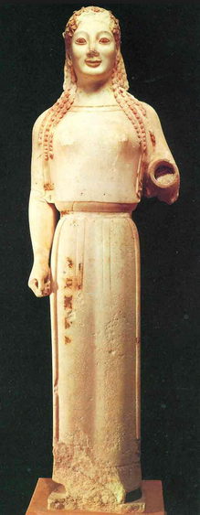

Figure 2: An Archaic Greek depiction of a young woman.

Human Figures, Culture Reflections Discussion

*Consider what you have learned so far about the representation of the human figure in Ancient Greece and Rome. How did their traditions of human figuration reflect their different cultural values and philosophies? What different types of images appear in each culture and why? What different styles? How do these images of the body compare to today’s images of the body? What different values do you think contemporary images of the body embody? What significance do we attach to “realistic” images as opposed to more idealized ones? What about abstraction?*

I discussed this topic at length in my portfolio essay for this lesson, noting that the Greeks were obsessed with bodies in motion. However, I have not yet contrasted the Greek and Roman styles of art—and the contrast is fascinating. Though both styles were somewhat realistic relative to the styles of art they succeeded—Archaic-style art, for instance—the Romans were still more interested in realistic depictions of bodies than the Greeks were. The Greeks often sculpted idealized versions of the human body, frequently in motion, while the Romans chose to sculpt less athletes and more everyday people (though they also placed an emphasis on analyzing the human body in movement—and at rest).

Miranda, I completely agree. In my discussion post, I also touched on the difference between the Greek and Roman’s style of portraying flaws. Like you pointed out, the Greeks were definitely gravitated much more heavily towards perfectionism than the Romans did. Also, I love your use of rhetorical questions throughout your post to demonstrate the points you were making!